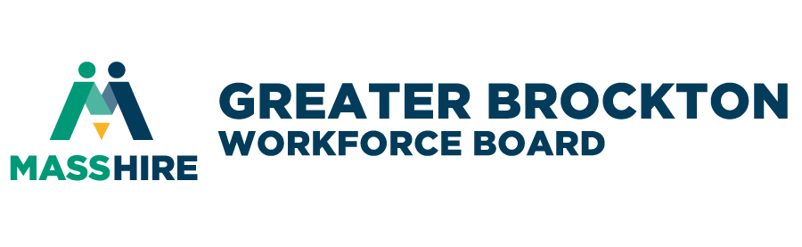

*DRAFT*

Annual Board Meeting Minutes

8:30 a.m. on Thursday, December 21, 2023

- CALL TO ORDER: The meeting called to order at 8:33 a.m. by the Board Chair, Mr. Joseph Lovetere
QUORUM PRESENT
- ROLL CALL:

Present: Joseph Lovetere–Chair, Linda Sacchetti, Jill Conlon, Nancy A. Chiappini, Joseph Mitchell,

Sasha Stadhard, Dan Evans, Suzanne Fernandes–Past Chair, Dr. Carine Sauvignon, Mary Waldron–Clerk
Thomas Thibeault (virtual), Paul W. Landerholm.
*Bold = excused absence

Not Present: Maria Fernandes, Nancy Chiapinni, and Donald Donnalson, John Murray
Ex-officio: Craig Kennedy
Staff: Jason Hunter, David Vincent, John Nesti Lorraine Albert, Michael Joseph, Ray Yancey, Hirondina Barbosa, Michele Ahern, Vanessa Labossiere, Shaleah Gilmer, and Rachel Cherry-Adams
Guests: Dr. Johan E. Uvin, UMass-Donahue Institute [via remote Zoom]
Judy Bower, MassHire Department of Career Services– via remote Zoom]
Dr. Elvio Ferriera, Director Career & Technical Education 6-12
Rick Cicchetti, R&D Trucking
Jake Maijala, Signature Healthcare

WELCOMING & OPENING REMARKS Chair, Mr. Joseph Lovetere welcomed the Board & guests.
MINUTES - VOTE: A motion made (Ms. Mary Waldron) and seconded (Mrs. Suzanne Fernandes) to approve the September 28, 2023, Quarterly Full Board meeting minutes. June 22, 2023, Annual Full Board meeting minutes approved by the board members.

- FISCAL YEAR FY2024 BUDGET FORECAST
- mASShIREgbcc UPDATE – Mr. John Murray
- Mr. Murray gave an overview of proposed budget FY24 for MassHireGBCC [UMDI] – Budget Narrative information shown on screen.
- MassHireGBCC Funding (projected) for FY24: $2,786,262.80. 24 FTEs
- 67% cut for the year.
- Increased $$$ for Adults and RESEA. The Carry-In $$$ are sustainable.
- masshiregbWB UPDATE – Mr. Jason Hunter
- Mr. Hunter gave an overview of proposed budget FY24 for MassHireGBWB ] – reading of the budget Narrative information summary.
- MassHireGBWB Funding (projected) for FY24: $3,090,111 15FTEs
- Non-Personnel Expenses: $1,944,596.
- Increase $$$ for Youth Wages.

- ???? re: MassHireGBWB organization professional auditing service: the service will continue with Anstiss.
  - Budget FY24 MassHireGBWB– VOTE/Mr. Jason Hunter/Mr. Joseph Lovetere
    - BACKGROUND
      - We are currently awaiting final budget figures from the Division of Career Services along with carry-in figures. The MassHireGBWB office is currently working on draft FY24 budgeting known figures and assumptions of level funding for several grants for FY24.
    - MOTION - VOTE
      - A motion was made (Mr. Bob Revil) and seconded (Ms. Linda Sacchetti) To accept the budget as read by Mr. Jason Hunter as the final draft budget for Fiscal Year 2024 for the MassHire Greater Brockton Workforce Board, empowering the Acting Executive Director and Manager of Finance to make budget modifications based on changes in funding streams.
      - The motion unanimously passed.
- career center business committee/
- Masshiregbcc executive summary 9-28-2023 –Mr. John Murray
- Cut in Dislocated Workers (DW) ??? this year.
- Goal increase for Adults [$17.50] DW [$22.00wage goals for this fiscal year.
- ??re: Adult entering employments??
- ????What measures are used for percentages (%)??
- Total Job Seekers Served for FY23 Final – 5,863
- Fiscal Year 2024 Job Seker Served Goal for FY24 -5,500
- Training initiatives - Mr. Jason Hunter
- MassHireGBWB Update
- Working with new CNA Healthcare vendor, Healthcare EDU
- CDL
  - 12 completions
  - 24-30 seats through the next year.
  - $47/hour average wage – good update
- Alternative Fuels & Emissions/Diesel Tech training – We have the grant [CommCorp].
  - Certificate Program begins January 2024
  - Contact: MassHireGBWB staff member Mr. Michael Joseph
- Apprenticeship Program--Early Childhood Headstart/Daycare --MassHireGBWB partnership with Self-Help, Inc. and the MassHireGBCC
- YOUTH SERVICES – Messrs. David Vincent and Michael Joseph
- SUMMER JOBS PROGRAM [6-week program] – Mr. David Vincent
  - 800 Youth Applicants along with the WAVE Volunteer program [14-15-year-olds, revamped this year, with skill base, career opportunities, Arts and Gardening].
  - 58 engaged employers
  - 33 Employers participated this year.
  - Mr. Vincent sent out Thank You to Board member, Ms. Linda Sacchetti.
- Ms. Sacchetti of the Brockton Transit Authority shared the success story of their Summer Jobs intern at the BAT this summer 2023.
  - The 2023 Summer Jobs Empowering Future Leaders Award Ceremony was held on Thursday, September 31st; it was another success. The event was well put together by our staff members; there were over 120 people in attendance at the Thorny Lea. There was a spectacular panel of youth and business leaders. The daycare, Kiddie Haven won the Leaders’ Award.
- 275 youth and 32 employers participated this year in the Summer Jobs Program.
  - 2023 Summer Jobs Backyard Boogie Event, on Friday, September 1st. – this event was well attended.
- Fall Line-up for Youth Center – Mr. Michael Joseph
  - Ongoing Info sessions this going on now on Thursdays at the MassHireGBWB Youth Center (Youth Services Department).
  - Upcoming programming, please see distributed flyers in Board Book.
- Resource Fair coming up – October 29th, 3:00-6:00 PM
- Mini Job Fair, December 7th
  - Mr. Joseph discussed the creation of a youth board and identifying potential youth candidates.
- Young people in programming
- Getting their view
  - Young Adult Initiatives Committee – Last meeting September 13, 2023
    - We have a new YAIC co-chair – Ms. Denillda Varela, a student at Massasoit Community College.
  - EXECUTIVE DIRECTOR REPORT- Mr. Jason Hunter MassHireGBWB Board Vice-Chair
    - MassHireGBWB Announcement: Workforce Outlook, Construction and Building Trades in SE Massachusetts, Thursday, November 9, 2023, from 11:00 AM to 1:30 PM @ Thorny Lea Golf Club, Brockton MA.
    - Ms. Martel gave brief remarks on her experience with the MassHireGBWB Board.
    - The Board Chair added: Ms. Martel made great connections with student outreach in the community.
- Chair’s Closing Remarks & Announcements -- Closing by Board Chair, Mr. Joseph Lovetere
- Artcles of Interest- Mr. Jason Hunter
- ADJOURNMENT – A motion made and seconded to adjourn at 9:48 a.m.
NEXT MEETING: DECEMBER 21, 2023

