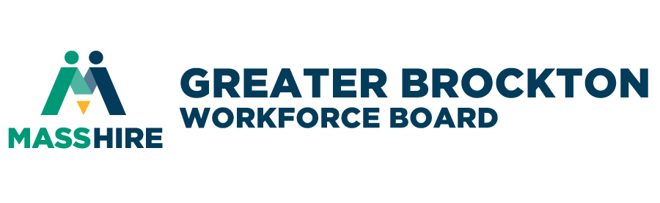

MEETING MINUTES

Young Adult Initiatives Committee (YAIC) Meeting

1:00 p.m. Wednesday, September 13, 2023
Location: Hybrid Meeting

QUORUM PRESENT

- CALL TO ORDER: The event started with a welcome from YAIC Chair, Ms. Mary Waldron, MassHireGBWB at 1:03 p.m.

- ROLL CALL
Present: Mary Waldron – YAIC Chair, Denillda Varela – YAIC Co-Chair, Bob Revil, Solange Alves, Paula Fontes,
Ashley Guda, Paul Bello, Liz Westbrook, George Brickhouse, Maria Fernandes, Courtney Logan, Diane Hill, Courtney Selig, Elizabeth Hennessy
ABSENT: Dan Fitzgerald, Susan McSweeney, Kristin Ferioli, and Kristi Glenn
*Bold = excused absence
Guests: Ms. Ellie Cooper, Student Navigator (Pride Center), BSU
Ms. LaCasha Figueroa, Student Navigator (LGCIE), BSU
David Phillips, FBMS
Krystel Love, New Heights Charter School-Brockton
Madeleline Story, WHRSD
Jay DeGrace, City of Brockton Mayor’s Office,
Alyssa Cribben, BAMSI Young Adult Access Center,
Jackie Joseph, ARTs
Joshua Jackson
Lorcens Bellevue
Staff: Jason Hunter, David Vincent, Rachel Cherry-Adams, Hirondina Barbosa, Wollign Bellevue, David Edwards,
Michael Joseph, and Shaleah Gilmer, Vanessa Labossiere, and Victoria Delannoy
- WELCOME/INTRODUCTIONS – Ms. Mary Waldron
- Welcome everyone – Members, Guest, and Students
- Introductions around the table.
  - Introduction and vote for new Vice-Chair Student, Ms. Denillda Varella.
- MINUTES: Review of Prior Meeting Notes from previous meeting(s) – May 10, 2023
The Meeting Minutes from May 2023 were approved by the YAIC Committee
- MassHire Greater Brockton Youth Program Updates
- Youth Services
WIOA Title I Occupational Training
- Ms. Victoria Delannoy, Youth Career Councelor
- For 18-24 years old, includes Medical Assistants, CNAs, IT and CDL
  - CDL training – there are 5 – 10 slots available.
  - Looking for 10-15 Youth who are 18-24 years old, high school graduates, unemployed or underemployed.
- Ms. Hirondina Barbosa, Youth Career Counselor
Banking and Finance recap:
- 6-week hybrid program [starting October 2023]. Coursework is online and in person 2x a week (unemployed or underemployed).
- Looking for 10-15 Youth who are 18-24 years old, high school graduates, unemployed or underemployed.
- At the end of training, they receive three (3) certifications: Bank teller, Customer Service, and Universal Banker

- Ms. Shaleah Gilmer, Youth Career Counselor
- Media Moguls - 6-week training for HS grads will begin in October, we have 10 slots available. All interested candidates can contact me via email (sgilmer@massshiregbwb.org)
  - E.g., Videography
  - Deadline sign-up October 9th, on-line registration.

- Mr. Michael Joseph, Recruitment & Engagement Liaison
- Hosting info session each week; signup –will send email to YAIC
  - Every Thursday, 11:30 to 1:00 PM and 3:30 to 4:30 PM.
- Mr. Joseph announced to the YAIC group: If you know of any youth that maybe interested in our potential Youth Board Member(s) (consulted with Ms. Mary Waldron, Mr. David Vincent, and Jason Hunter)– Looking for Youth Voices:
  - Five to six (5-6) individuals/young people to fill these positions 14–24-year-olds, who live or go to school in our region, learn our organization’s mission [there ae 10 schools in our region]. Gave all other requirements:
    - Have great communication skills
    - Good listening
    - Approachable
    - Work in team environment
    - Civic engagement
    - Reach out to our young people.
  - MassHireGBWB is also looking to have organizations interested in partnering with us or co-hosting on our Youth Networking event, please contact him (Michael Joseph) at mjoseph@MassHireGBWB.org (deadline October 26th)
- Fall Internship Program
  - Looking for 20 full-time internships youth [16-21 years old] 100 hours work time for various opportunities. Deadline is October 20th. Mr. Joseph will get more information to YAIC group.
- Networking event Partnering 2-3 organizations – to cohost with MassHireGBWB, October 26, 2023. Any ideas contact Mr. Joseph by September 20th.
- Mr. David Edwards, Connecting Activities (CA) Coordinator
- Successfully closed out 2022-2023 School Year
- Now enteringFY23-24 school year (14 schools participate, meet monthly).
- At this current time there is nothing much to report out yet.
- Good news – refunded for level funding.
- Convening with all schools in our district in our region – something new. Goal to build CA network – what is happening at State level and our region.
- Congratulations, David Edwards by Ashley Guba – Stoughton Public Schools.

- Partner Program Update
- Paula Fontes, New Heights Charter School [new role this year: College Transition & Alumni Coordinator]
  - College Fair September 27, 2023 - All are invited. Please feel free to send your students over! (Flyer in chat)
- Solange Alves, Brockton Public Schools
  - Just started: 200 kids; still enrolling.
- Lacasha Figuero/Ellie Cooper, BSU
  - Summer Bears program – Incoming Freshman students; 5-week program. MassHireGBWB was part of that program (25 students).
- Courtney Logan, Safe Corners/Old Colony YMCA
  - Partnering with FBMS – homelessness. The WISP Program – Sherry just joined us.
  - They are hiring Outreach workers; they have to be 21 years old.
- David Phillips, FBMS
  - Working with families – Employment Specialist
- Jackie Anne Joseph, A.R.T.S Foundation Inc
  - www.artsfoundationinc.org - FY24 Deadline October 24, 2023
    - Contact us via email at: brocktonculturalcouncilinfo@gmail.com.
  - Young people (25 youth) just wrapped up summer programming/Jamboree at the Fairgrounds – showcased their arts.
  - Jackie was recently accepted on the Brockton Cultural Council’s Board.
    - Local grant October 13th due date.
- .Krystel Love, New Heights Charter School-Brockton
  - College Fair, May 11, 2023 @ 5:00-7:00 PM -Looking for company referrals for Job Fair.
- Guest Speaker
Malik Williams, Executive Producer, Composer at Reel Sync Music, Secret Society of Black Creatives and Co-Chair at Audio Engineering Society. 617-828-2272 malik@reelsyncmusic.com / https://ssblackcreatives.com/
- Presented material on “The Business Music”, “Audio Postproduction”, career and program opportunities for young people interested in the entertainment industry.
- Other Business

- Adjournment – No business conducted; the meeting adjourned at 2:10 p.m.
NEXT MEETING
Next Meeting – Wednesday November 8th, 2023
Time: 1:00PM

