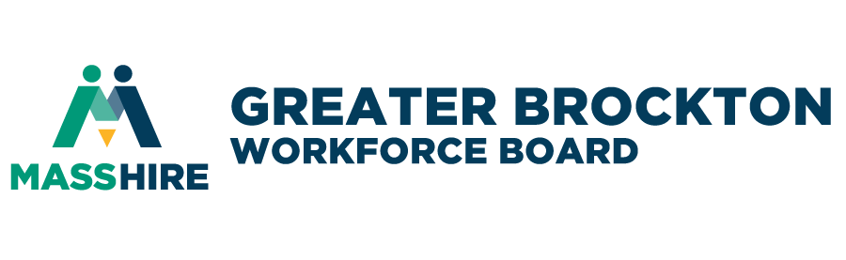

MEETING NOTES

Young Adult Initiatives Committee (YAIC) Meeting

1:00 p.m. Wednesday, January 8th, 2025
Location: 34 School Street, Brockton MA,02301 Hybrid/ZOOM

- CALL TO ORDER: The event started with a welcome from YAIC Co-Chairs at 1:04 p.m.

- ROLL CALL
Present: Denillda Varela–YAIC Co-Chair,
- Mary Waldron – Chair of MasshireGBWB YAIC & Executive Director of the Old Colony Planning Council
- Robert M. Revil – MassHireGBWB Board member & member of the IBEW Local Union 223 JATC
- Jaclyn Malloy – Brockton Housing Authority
- Ellie Cooper – Bridgewater State University
- Solange Alves, Brockton Public Schools
- David Phillips Brockton Father Bills/ MainSpring
- Cassandra - Brockton Father Bills/MainSpring
- Dr. Corine Sauvignon – Massasoit Community College
- Paula Fontes – New Heights Charter School
- Shika – My Life My Choice out of Boston
- Jean Brewster
- Brian Mitchell
- Jennica- Eddison Academy Youth
- Tatyana M. – CVA
- Brianna M. – CVA
Staff: Michael Joseph, David Vincent, David Edwards, Tyra Fernandes, Shaleah Gilmer, Moudestine Williams
- WELCOME/INTRODUCTIONS – by Co-chair, Ms. Denillda Varela & Chair, Mary Waldron
- Welcome everyone – Members, Guest, and Students
- Introductions around the table
  - Name and your organization.
  - Mary Waldron requests a moment of silence for Sheila Sullivan and Raymond Yancy.
- MINUTES: Review of Prior Meeting Notes from previous meeting(s)
The Meeting Minutes of November 13th, 2024 were approved.
- MassHire Greater Brockton Youth Program Updates by David Vincent:
- Programs coming up in February, flyers have been shared. —If you have not received flyers, we can send them out to you.
    - Internship Program: if you have any employers needing interns or any young people (16-24yr olds) looking for an internship opportunity, please share.
    - Banking and Finance Program: trains young people on how to be bank tellers, the goal is 10 young people looking for training.
    - Google IT Program: license with google to offer different career opportunities such as project management, cyber security, digital marketing.
    - Media Moguls: partnering with Brockton Community Access (our local cable station) and they will be assisting with training young people on how to learn about different equipment, broadcasting, content creating, very hands-on in the community etc.
    - CNA Program: 10 seats available, looking for referrals.
- I want to establish a focus group that is comprised of young people, parents, and community members. Allowing us to gather information/feedback on what they want to see for upcoming training opportunities/services.
    - Looking for stakeholders, if any professionals on the board would like to participate, we will be sending out a flyer to help with recruitment.
- Highlight new member of our team, Moudestine Williams, is the new Job Coach for the Youth Services Department. She will be assisting with the upcoming programs as well.
- Mr. David Edwards – Connecting Activities Coordinator Updates
- Currently we have an event tomorrow that we are hosting for our Winter Entrepreneurship Competition. We are highlighting this event tomorrow to see if this is something we can add in moving forward, because we normally have this contest in the spring. We thought since the numbers we have been seeing the past couple of years, it might be possible to insert a Winter session for the Entrepreneurship Competition. So, we will see how tomorrow’s event goes and if it is successful, it will determine if we can host two different dates for the winter and spring season for The Pitch Competition.

- Partner Program Update (Share information you are working on currently)
- Paula Fontes: On the Spot admissions day coming up on Tuesday with 7 colleges, they will be meeting with the students to let them know if they are accepted.
- Solange Alves: Also have an on the spot for our January graduates coming up with Massasoit community college. Currently waiting for their response.
    - We have a new principal, Dr Presime
    - Wrote a grant for $50,000 but only received $34,000 and must split it with BHS. Thoughts of starting the CNA program back up since the last program was successful, but the money isn’t enough with the rate of $2,000 per student. Will be searching for other grant opportunities.
- Robert M. Revil: IBEW will be opening applications in August. If any youth are interested in a pre-apprenticeship program, they can go to Building Pathways South and contact Evon Tobi to try and start a career in the Union Building Trades.

- Review Current Member List
- Michael Joseph: I would like for us to go through our members list, who should we add on or reach out to?
- Jaclyn Malloy: If I may chime in, I had a meeting right before Christmas with the Family Resource Center, they do a lot with families and youth. This can be a contact to add, I will share the contact information that I have, and you can reach out to them!
- Thank you from Mary Waldron and Michael Joseph.
- Action Item for Michael Joseph to reach out to potential partners.
- Mary Waldron suggests that we share the recording of the meeting to our members.
  - Michael confirms that we have been recording and sharing the recordings online.
- Michael Joseph states that the current list that we have still needs updates as well.
- Mary Waldron: Just a reminder that it isn’t just Brockton, it’s the region. And if it is possible to have one of the staff from MassHireGBWB go through the contact list we have and ask specifically if they would like to continue being a part of the committee.
- Review Members Questionnaire Submissions – no discussion.
- YAIC Spring Retreat - BRAINSTORMING
  - Possible Dates/ Time? May 7th, 2025, 3-5PM – possible hold the date to be sent out.
  - Possible Locations? Library, Stonehill, MCC Downtown Location, Fuller Craft Museum,
    - Locations outside of Brockton as well: Abington, Avon, All of Bridgewater, Stoughton, Training center in Taunton.
  - Possible Theme and Topics? Mary Waldron states that the retreat will be an opportunity to get a deeper dive on all elements of Brockton Public Schools, and what each program has to offer for the youth.
Talking about our by-laws and what our mission statement is. This is the time to do this so in the spring we can connect before the fall comes.
  - Who should be invited? 50 People (Vendors/Members), High school Youth ages 16-24, Schools (Connecting Activities)
- Michael Joseph asks the group to keep the retreat in mind and to not hesitate to share any information or ideas that come to mind. Reminder that this retreat is for us! All of us as a community putting this together. Let’s be mindful of who we are bringing to the table and sitting down with.
- Denillda Varela: Yes, thank you Michael, we will revise in the next meeting.
- Mary Waldron: Happy New Year everyone and let’s keep in mind for the next meeting to share who we want to see come to the table.
- Adjournment – No business conducted; the meeting adjourned at 1:48 PM

NEXT MEETING
Time: March 12, 2025, 1PM.

