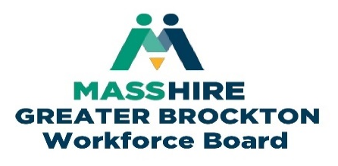

Young Adults Initiative Committee Agenda
Wednesday March 12th, 1:00pm
Location:
In-person at 34 School Steet, Mezzanine Floor Level Board Rm. Or on Zoom

PLEASE KEEP YOUR MIC MUTED

      - Welcome

      - Introductions

- Approve Prior Meeting Minutes:
  - Minutes for January 8th, 2025

- MassHire Greater Brockton Youth Program Updates:
  - Youth Services
  - Connecting Activities

- Partners Program Updates

      - Guest Speakers:

      - Jean Brewster
    - President and Co-founder of Greater Youth Resource Services Inc. DBA Randolph Educational Collaborative.

      - Dr. Ellie Paris-Miranda
    - Entrepreneur Professor at Wheaton College and founder of the Social Bookstore and Ice Cream Café, Brockton MA.

- YAIC Spring Retreat

- Other Business

- Adjournment

Next Meeting – Wednesday May 7th^{th}
Time: TBD
Location: TBD

